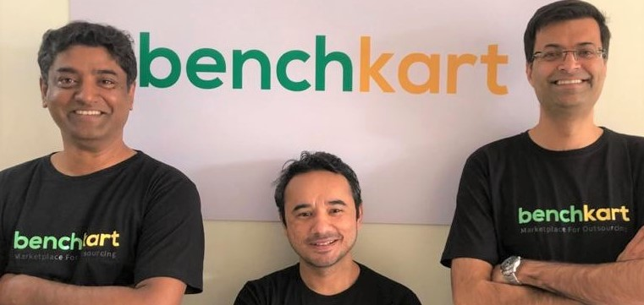

**Benchkart loves connecting great customers with great partners!**

We have always believed that all companies, big or small should have access to the finest Partner network to get their job done. For far too long, Outsourcing has been organized only FOR large companies and BY Large companies. Paradoxically however, it is the Start-Up, the Small & the Mid-Market company and those with lack of access to high quality internal digital teams, who really need support & guidance for their Digital Transformation journeys!!

The problem has been that these customers are not on the radar for most large Outsourcing companies, who are chasing larger clients & higher value workloads. Their GTM strategy is just not geared towards acquiring & servicing these clients – because the cost of acquisition, the internal bandwidth required to manage their workloads and the smaller ticket size of their projects, make them unviable in their larger scheme of things. And we all know, solutions designed for large enterprises, and then just put out there for “SME Customers” just don’t work!

The Partner network in IT/ITeS on the other hand, has also been largely unorganized beyond the top players. This creates big issues when a potential customer, which is not large enterprise, starts scouting for partners. Though there are plethora of partners which are available based on internet searches, references & listing sites, there are no processes which can assure the clients that their Projects are in safe hands. Anecdotally, there are examples of the same project being quoted widely varying amounts by different firms/ freelancers. The customer, by now is even more confused on how to proceed with what is a critical project in their Growth journey!

This is what we have set out to solve. Elsewhere, on the site (How it Works & FAQs), you will get a good idea of how we intend to do it. Do give us a chance to help you deliver on some of your critical projects & do provide us feedback if we are being true to our objectives!

Meanwhile, something about the Co-founders!

Kislay Kumar, our CEO, has spent 21 years after passing out of IIM Calcutta being part of MNCs like HUL, Asian Paints, Nokia & Microsoft. As part of the Leadership Team of many organizations and as advisor to many Start-ups as well as Small & Mid-Market companies, he has gained valuable lessons on what it takes to drive business success with a transparent, compliant & customer centric organization.

Akshay Sethi leads Business Development & Partnerships, with a passion to onboard the finest partners and manage their engagement with the platform. In a career spanning 16 years across organizations like Tata group, Vodafone & American Express, Akshay has worked extensively on driving business growth through Partner Network. His start-up experience with Stellr, in the digital distribution space has made him a big-time advocator for keeping it simple for our customers.

Anurag Rawat leads technology for Benchkart, having spent more than 12 years in this space, with companies like Accenture & Birla Soft. A serial entrepreneur, he is passionately invested in making sure that the Benchkart platform provides the highest value to its users – and they can outsource their most valuable work through us with complete assurance of it being #Customised #Curated #Cost-effective #Secure

We are just a mail away at [kislay.kumar@benchkart.com](mailto:kislay.kumar@benchkart.com); [akshay.sethi@benchkart.com](mailto:akshay.sethi@benchkart.com); and [anurag.rawat@benchkart.com](mailto:anurag.rawat@benchkart.com)